Data Analytics Capstone

Predicting Medicare Part D Drug Spending Patterns and Identifying Prescriber Outliers: A Data-Driven Framework for Pharmacy Benefit Management Formulary Optimization

Final Report

Angel Pena
Walsh College
QM640: Data Analytics Capstone
Dr. Sanhita Karmakar
Spring 2026 Term
June 1, 2026

GitHub Repository
All data files, analysis pipeline, figure-generation code, and report builders are publicly available at:
https://github.com/Apena87/QM-640-Quantitative-Methods-Capstone
Abstract
Problem. Part D gross drug spending climbed from $103.7B in 2013 to $275.8B in 2023 (166% over the decade), with beneficiary enrollment growing only 45% in the same window. Existing CMS releases publish drug-level, prescriber-level, and program-level files separately; no single analysis ties them together with Open Payments, social determinants, and industry payments in a form a PBM can actually use. Solution. This project stitches those sources into one pipeline that answers five questions: an OLS regression on drug attributes; one-way ANOVA plus a nested SDoH-versus-insurance OLS at the state level; NPI-linked logistic regression with specialty fixed effects on Open Payments exposure; K-means segmentation of the drug portfolio validated three ways; and a counterfactual savings simulation with bootstrap intervals plus a biosimilar overlay. Data. CMS Part D Grand Totals (2013-2023), Part D Spending by Drug for 3,598 drugs, the full 26.8M-row Prescribers by Provider and Drug file (1.10M unique NPIs), 14.7M rows of CMS Open Payments, BRFSS chronic-disease prevalence and ACS demographics for all 51 U.S. jurisdictions, plus BLS CPI-U and Medical CPI. Technology. Python on a single CPU; pandas, numpy, statsmodels, scikit-learn, scipy, pyarrow, and matplotlib do the work; reportlab and python-docx render the deliverables. Results. The drug-level OLS hits R² = 0.920 (5-fold CV R² = 0.918, n = 2,756). State explains less than 1% of prescriber brand-share variance (F = 180), but the SDoH block alone reaches R² = 0.53 against 0.005 for insurance coverage by itself. Specialty drives 13.9% of brand-share variance (F = 5509); inside specialty, higher Open Payments exposure raises the odds of above-median brand prescribing. K-means at k=4 (Silhouette 0.333, DBI 1.007) yields four drug segments: High-Spend High-Growth (Eliquis, Ozempic top the list), High-Cost Specialty, High-Volume Generic, and Low-Impact Declining. The savings simulation puts the annual opportunity at $9.9B to $19.8B (95% bootstrap CI $9.6-$10.3B at the 50% floor); adding biosimilar substitution pushes the combined figure to $14.1B at 50%. Implementation area. Outputs are structured for direct use by CMS, PBMs, Medicare Advantage plan analysts, and health-system pharmacy committees designing formulary tiers, prior-authorization rules, or prescriber engagement programs.

Introduction
Prescription drugs are one of the fastest-growing line items in U.S. healthcare, and Medicare Part D is the program where that growth shows up most clearly. Part D covered 50.8 million beneficiaries in 2023 (CMS, 2023a) and booked $275.8B in gross drug costs, up from $103.7B in 2013 - a 166% jump over a decade. Per-beneficiary spending climbed 83.7% in the same window, well ahead of the 45% growth in enrollment. MedPAC (2024) and ASPE (2022) treat this gap as a real threat to Trust Fund solvency. The work below pulls the relevant CMS files together with Open Payments and state demographics so a pharmacy benefit manager (PBM) can actually use the data to decide where to intervene.
Background and Context
Two things about Part D make it tractable for quantitative analysis. The cost side is extraordinarily concentrated: brand-name drugs represent 85.2% of total cost on roughly 15% of claims, and the per-claim cost ratio between brand and generic drugs is about 33 to 1 ($976 versus $29.25). Niu et al. (2024) trace most of the recent growth to specialty drugs concentrated in a handful of high-cost classes. The prescriber side is the opposite of concentrated: Rosenberg et al. (2018) map wide regional variation in Part D prescribing, and Mitchell et al. (2021) report a consistent association between industry payments and brand-name prescribing.
Put those two features together and there is room for a model that combines drug attributes, prescriber characteristics, and the geography around the prescribers. The CDC Behavioral Risk Factor Surveillance System (BRFSS) and the U.S. Census Bureau American Community Survey (ACS) supply the demographic anchors, and CMS Open Payments makes the provider-industry money flow visible. The Congressional Budget Office (CBO, 2022) gives the price-versus-utilization framing: price and mix do most of the work, not enrollment. The per-beneficiary trend in this report tells the same story.
The audience for the analysis is wider than CMS alone. Medicare Advantage plan sponsors, PBMs, self-insured employers, and health-system pharmacy committees all need to decide which drugs go on which tier, where to require prior authorization, and which prescribers to talk to. None of those decisions are currently anchored in a single integrated quantitative view; the work below tries to be that view.
Problem Statement
This study sets out to explain Y = drug-level Part D spending and prescriber brand-versus-generic share using X = a mixed bag of drug attributes (claims volume, unit cost, beneficiary breadth, manufacturer count, dollar growth), prescriber characteristics (specialty, state, Open Payments exposure), and state-level demographics (uninsured rate, share aged 65+, diabetes/hypertension/obesity prevalence, household income, college attainment). The window is 2013-2023; the geography is all 51 U.S. jurisdictions. Success is judged on R² and cross-validated R² for the OLS work, F and eta² for ANOVA, Silhouette and Davies-Bouldin for K-means, pseudo-R² and odds ratios for the logistic, and a bootstrap 95% CI around the headline savings number.
Purpose of the Study
The point of the study is to build something a payer or PBM analyst can use. The five research questions split the problem into manageable pieces: what predicts drug spending growth (RQ1); how brand prescribing varies across states and which demographic factors explain that variation (RQ2); whether industry payments correlate with brand prescribing once specialty is controlled for (RQ3); whether the drug portfolio breaks into clean segments useful for tier design (RQ4); and how much money would actually be on the table if outlier prescribers regressed toward their specialty median and biosimilars displaced their reference biologics (RQ5).
Research Problems / Research Questions
The work is laid out as five research questions. The template asks for four, but the unsupervised-segmentation problem (RQ4) and the counterfactual savings estimate (RQ5) really are two different kinds of analytic question, and PBM decision-making needs both.
RQ1: Which drug attributes predict total Part D spending growth from 2019 to 2023?
RQ2: Do brand-versus-generic prescribing rates vary across states, and which SDoH and insurance factors explain that variation?
RQ3: After accounting for specialty fixed effects, does Open Payments exposure correlate with higher-cost prescribing?
RQ4: Does unsupervised clustering pull out distinct drug utilization profiles with meaningfully different mean per-beneficiary cost?
RQ5: How much annual Part D savings would actually be available if above-median prescribers regressed to their specialty median, and what does adding biosimilar substitution do on top of that?
Contributions and Expected Value
Practical contribution
The work outputs a ranked list of specialties, states, and drug classes where PBM intervention is most likely to pay off. The savings headline is $9.9B-$19.8B per year (95% CI $9.6-$10.3B at the 50% floor), which is large enough to budget outreach against. Drilling into the specialty breakdown puts Nurse Practitioner, Family Practice, and Internal Medicine at the top of the targeting list.
Technical contribution (methods and models)
On the methods side, the project shows how to combine very different file sizes (an 11-row program-totals sheet, a 3.6K-drug pivot, and a 26.8M-row prescriber panel) inside one reproducible workflow. The new pieces relative to typical interim analyses are a hierarchical decomposition of brand-share variance into insurance and SDoH blocks tested with partial F; an NPI-linked logistic on Open Payments with specialty fixed effects; a 1,000-iteration bootstrap on the savings number plus a 30-70% substitution-rate sweep; and a state-by-specialty peer benchmark used as a stand-in for Hospital Referral Region effects when ZIP-level prescriber addresses are not available.
Value to stakeholders / target users
Different users want different things from this. CMS and MedPAC get a reproducible savings benchmark they can re-run against next year's files. PBMs and Medicare Advantage plans get an outlier-detection method that respects clinical norms inside a specialty rather than punishing everyone in endocrinology for prescribing what endocrinologists prescribe. Pharmacy committees get a paper trail for prior-authorization rules. All of the code and CSVs are public, so anything in here can be challenged, replicated, or extended.

Literature Review
Literature Review Approach
Sources came from two paths. The peer-reviewed work was pulled from PubMed and Google Scholar using keyword combinations like Medicare Part D AND (spending OR expenditure), pharmaceutical industry payments AND prescribing behavior, generic substitution AND Medicare, and K-means clustering AND prescribers. The policy and benchmark statistics came from the obvious federal sources - ASPE, CBO, CMS, MedPAC, the Dartmouth Institute - which were canvassed directly. A few citations were picked up by tracing forward and backward from two anchor papers (Mitchell et al., 2021 and Niu et al., 2024). To make the cut, a source had to be relevant to at least one research question, use peer-reviewed methods or federally validated data, and, if empirical, be reasonably recent (last decade for the journal articles; older for the methodology texts).
Summary of Key Literature
Table 1
Literature Relevance Matrix
Author (Year) | Domain | Dataset | Method | Key Findings | RQ Linkage
ASPE (2022) | Federal policy | IQVIA National Sales Perspective | Trend analysis | 16% overall prescription drug spending growth 2016-2021; brand drugs 80% of cost | Program-level benchmarks for RQ1 and RQ2
CBO (2022) | Federal policy | CMS + manufacturer | Decomposition | Price (not utilization) drives most spending growth | Validates RQ1 focus on price/intensity over enrollment
Mitchell et al. (2021) | Health policy | Open Payments + Part D | Systematic review | Industry payments correlate with brand prescribing | Primary empirical support for RQ3 hypothesis
Sharma et al. (2018) | Health services research | Open Payments + Part D 2014 | Logistic regression | Industry payments raise brand-prescribing odds 1.4-8x by payment type | OR benchmarks and variable selection for RQ3
Niu et al. (2024) | Pharmacy economics | Medicare Part D Spending file | Concentration + clustering | 95% of total cost from <20% of drugs | Directly informs K-means approach for RQ4
Yeh et al. (2016) | Clinical research | MA payment database + Part D | Cross-sectional | Payments correlate with brand statin prescribing in MA | Proof-of-concept for national Open Payments analysis (RQ3)
MedPAC (2024) | Federal policy | CMS + plan-level | Trend + program review | >51M Part D enrollees in 2023; brand drugs dominate growth | Corroborates CMS magnitudes; contextual framing for RQ1
Choudhry et al. (2011) | Clinical research | Patient-level claims (MI cohort) | Intervention study | Full generic coverage shifts substitutable brand use ~50% | Sets substitution-rate floor for RQ5
Buttorff et al. (2020) | Pharmacy economics | Medicare Part D PDE 2006-2016 | Logistic + descriptive | Plan-level GDR varies widely within classes; state averages 0.83-0.88 | Benchmark for RQ2 within-class and geographic variation
Rosenberg et al. (2018) | Public health informatics | Medicare Part D claims | Geographic visualization | Nationwide variation in Part D drug class use | Validated predictor set for state-level RQ2 model
Cohen (1988) | Methodology | N/A | Power analysis | Sample size and effect-size conventions | Anchors minimum sample size computation
Mooi & Sarstedt (2011) | Methodology | N/A | Multivariate textbook | >=50 observations per cluster recommended | Anchors K-means sample size minimum
Note. Twelve sources across federal policy, health services research, pharmacy economics, and methodology. Full citations appear in the Bibliography.
Thematic Synthesis
The literature converges on a few uncomfortable facts. The most basic is the structural pricing gap: brand and generic drugs are not priced at all alike in Part D, and the gap is large, sticky, and well-documented (ASPE, 2022; CBO, 2022; Niu et al., 2024). That alone makes substitution worth modeling. Where the literature gets pointier is on the prescriber side - industry financial relationships keep showing up as predictors of brand prescribing across different datasets and methodologies (Mitchell et al., 2021; Sharma et al., 2018; Yeh et al., 2016), which is the empirical hook for RQ3. The drug portfolio itself is also not uniform; Niu et al. (2024) document the spending concentration that makes K-means segmentation actually useful for RQ4. Rosenberg et al. (2018) round out the geography story: prescribing patterns really do vary across U.S. regions, which is why RQ2 has to model state and SDoH explicitly rather than treating everyone like a single national population.

Materials and Method
Data Description, Source, and Access
The empirical backbone is three CMS administrative files, downloaded directly from the data.cms.gov portals. CMS Open Payments 2023 was added for the RQ3 industry-payment work. State-level BRFSS chronic-disease prevalence and ACS demographics give the RQ2 SDoH model something to regress on, and BLS CPI-U plus Medical CPI series let us decompose nominal versus real growth for the committee-feedback section. Everything is public; Table 2 below lists what was used, and Appendix A contains the variable-level data dictionary.
Table 2
Dataset Overview
Dataset | Coverage | Size | Primary Use
CMS Part D Grand Totals | 2013-2023 (11 yr) | 11 rows x 30 cols | Program-level annual spending and enrollment
CMS Part D Spending by Drug | 2019-2023 (5 yr) | 3,598 drugs x 50 cols | Drug-level spending, claims, unit cost
CMS Part D Prescribers by Drug | 2023 | 26.8M rows -> 1.10M unique NPIs | Prescriber-drug claims, costs, state, specialty
CMS Open Payments (General) | 2023 | 14.7M records | NPI-linked industry payment exposure (RQ3)
BRFSS + ACS state demographics | 2022-2023 | 51 jurisdictions x 7 indicators | SDoH and insurance predictors (RQ2)
BLS CPI-U and Medical CPI | 2013-2023 | 11 yr x 2 series | Real vs. nominal growth normalization
Note. All datasets are publicly available and continuously updated by their source agencies. The full prescriber panel (26.8M rows) is the analytic base for RQ2, RQ3, and RQ5.
Inclusion and Exclusion Criteria
Drugs with zero 2023 spending were dropped before RQ1 and RQ4 (leaving 3,598 drugs). Prescribers with fewer than 20 annual claims were excluded from RQ2, RQ3, and RQ5; the noise from low-volume providers swamps the signal otherwise. CMS small-cell suppression (records with fewer than 11 beneficiaries) was kept as missing rather than imputed for the beneficiary count variable - the primary identifiers (NPI, specialty, state, drug name, claim count, drug cost) are complete on the full prescriber file regardless. When computing the state-by-specialty benchmark, cells with fewer than 20 prescribers were dropped so the median was not driven by one or two providers.
Exploratory Data Analysis
Every dataset was inspected before any model was fit. The program-level trends (Figures 1-4) show sustained growth across total cost, brand share, per-beneficiary cost, and Low-Income Subsidy share - the kind of picture that motivates the whole project. The drug-level distributions (Figures 5-7) are heavily right-skewed in both spending and unit cost, which is why every OLS predictor in this report goes through a log transformation before it hits the regression. The prescriber profile (Figure 11) makes clear that internal medicine and family practice carry the volume, while the high-brand-share specialties relevant to RQ3 and RQ5 are endocrinology, rheumatology, and hematology/oncology. Table 3 summarizes what each EDA view contributed to the modeling choices that followed.
Table 3
EDA Insight Summary (Linked to Research Questions)
Figure | What it Shows | Key Insight | Decision / RQ Link
1 | Total Part D gross cost 2013-2023 | 166% growth; CAGR ~10.3% | Baseline benchmark; motivates RQ1
2 | Brand/generic cost share and claim-cost trend | Brand 85% of cost on ~15% of claims; 33x price gap | Motivates RQ3 and RQ5
3 | Per-beneficiary cost trend | 84% per-bene growth vs. 45% enrollment | Confirms intensity-driven growth
4 | LIS vs. non-LIS cost share | LIS share ~48% of cost on smaller enrollment | Adds LIS as RQ2 covariate
5 | Top 20 drugs by 2023 spending | Eliquis, Ozempic, Jardiance, Trulicity, Xarelto top | Names targets for RQ4 cluster narrative
6 | Unit cost distribution (log10) | Bimodal; spans 5+ orders of magnitude | Log-transform OLS and K-means features
7 | Brand vs. generic cost per claim | Brand $976 vs. generic $29.25 | Quantifies RQ5 per-claim differential
11 | Top 15 prescriber specialties by drug cost | Internal/family medicine dominate volume | Within-specialty design for RQ3 and RQ5
Note. Figure numbers refer to Visual Evidence in the Results section. LIS = Low-Income Subsidy.
Research Hypotheses
Each research question is paired with a null and an alternative, evaluated at alpha = .05.
RQ1: H0: All five drug-level OLS coefficients equal zero. Ha: At least one coefficient is non-zero.
RQ2: H0: Mean prescriber brand share is equal across all 51 jurisdictions. Ha: At least one state mean differs.
RQ3: H0: Mean prescriber brand share is equal across specialties, and Open Payments exposure has zero effect on the odds of above-median brand prescribing after specialty adjustment. Ha: At least one specialty mean differs and/or the Open Payments coefficient is non-zero.
RQ4: H0: The k=4 K-means partition does not produce clusters whose mean spend, unit cost, or dollar growth differ significantly. Ha: At least one cluster-level mean differs.
RQ5: H0: The annual savings achievable by shifting above-median prescribers to the specialty-median brand share is zero (95% CI contains zero). Ha: The 95% CI lies strictly above zero.
Minimum Sample Size Computation
Power was set at 0.80, alpha at .05, and effect sizes at Cohen's medium conventions throughout. OLS uses n >= L/f^2 + k + 1 with f^2 = 0.15; one-way ANOVA uses an iterative search of the noncentral F distribution at f = 0.25; K-means follows the 50-per-cluster heuristic from Mooi and Sarstedt (2011); RQ5 uses the coefficient-of-variation form n = (z(sigma/mu)/E)^2 with z = 1.96, sigma/mu = 0.5, and E = 5%. Table 4 prints minimum n alongside what we actually got from the data. The achieved counts blow past the minimums by a factor of dozens to thousands depending on the RQ, so power is not a concern for any of the inferential tests below.
Table 4
Minimum Sample Size Computation per Research Question
RQ | Test | Min n | Achieved n | Status
RQ1 | Multiple OLS Regression + 5-fold CV | 92 | 3,404 | Exceeded
RQ2 | One-way ANOVA (full file) + Multivariable OLS (BRFSS+ACS) | 567 | 995,699 | Exceeded
RQ3 | Specialty ANOVA + Within-Specialty Logistic Regression | 360 | 650,861 | Exceeded
RQ4 | K-means clustering | 200 | 3,598 | Exceeded
RQ5 | Sample mean + 1,000-iteration Bootstrap CI | 385 | 995,954 | Exceeded
Note. alpha = .05, power = 0.80 throughout. Effect sizes per Cohen (1988); K-means per Mooi and Sarstedt (2011). Values computed in analysis_v2.py.
Statistical Methods and Justification
RQ1 uses OLS multiple linear regression with 5-fold cross-validation. The research question wants directional and magnitude estimates for log-transformed drug attributes against log spending, conditional on the other predictors, which is squarely what OLS does. The five predictors are log(claims), log(unit cost), log(beneficiaries), number of manufacturers, and log(dollar growth). Cross-validation is there to catch overfit. A year-over-year velocity feature was tried at the committee's suggestion and rejected (full numbers below); a Multiple Imputation sensitivity was also run for the small-cell suppressed beneficiary variable, and complete-case OLS was kept as primary for reasons that show up in the results.
RQ2 starts with a one-way ANOVA on prescriber brand share by state, then moves to a hierarchical OLS that breaks state-level brand share into an insurance block (uninsured rate alone) and an SDoH block (age 65+, diabetes/hypertension/obesity prevalence, household income, college attainment). Partial F-tests measure how much each block contributes. The ANOVA answers whether state matters at all; the hierarchical OLS answers what is actually doing the work.
RQ3 mirrors that structure for specialty. A one-way ANOVA on prescriber brand share by specialty establishes the baseline effect, after which a within-specialty logistic regression takes the binary outcome (above versus at-or-below specialty median brand share) and regresses it on log(Open Payments dollars + 1) with specialty fixed effects. The fixed effects exist to absorb the case-mix differences between, say, endocrinology and dermatology so that the payment coefficient is not just picking up specialty.
RQ4 is K-means on three standardized log features (claims, unit cost, dollar growth), validated by the elbow method, Silhouette, and Davies-Bouldin across k = 2 through 8.
RQ5 is a counterfactual savings simulation. For every prescriber whose brand share sits above their specialty median, the excess brand claims get multiplied by the substitutable-pair brand-to-generic cost differential, and the result is summed across all qualifying prescribers. A 1,000-iteration bootstrap gives a 95% CI; a sensitivity sweep from 30% to 70% substitution rate brackets the estimate. A state-by-specialty benchmark approximates the HRR effect when ZIP-level addresses are not available. A biosimilar substitution scenario for eight reference biologics (Humira, Remicade, Lantus, Neulasta, Procrit/Epogen, Avastin, Herceptin, Rituxan) sits on top of the generic-conversion baseline.
Original Work: Data Splitting, Training, and Accuracy
The RQ1 OLS uses an 80/20 train/test split plus 5-fold cross-validation. In-sample R² is 0.920; cross-validated R² is 0.918 (SD = 0.012) over n = 2,756 drugs - the CV figure is essentially the same as the in-sample figure, which is the cleanest possible sign that the model is not overfit. The RQ3 logistic uses all 650,861 qualifying prescribers across the 20 specialties that survive filtering; specialty fixed effects are absorbed before estimation. The RQ5 bootstrap resamples prescribers with replacement, recomputes the per-prescriber savings on each draw, and reports the 2.5th and 97.5th percentiles of the 1,000 bootstrap totals. The whole pipeline runs end-to-end in under five minutes on a single CPU and is reproducible from the GitHub repository.

Architecture and Workflow
System Overview
Everything flows in one direction: public CMS, BRFSS, ACS, and BLS files at the source end, a Python pipeline in the middle, deterministic CSV outputs and figures at the output end. Two builders (reportlab for PDF, python-docx for this document) read those CSVs at build time and render the final reports, which means there are no hardcoded numbers anywhere - if a CSV value changes, the next rebuild picks it up. The pipeline is organized into ingestion, cleaning, EDA, feature engineering, modeling, evaluation, and reporting stages, each described below.
Architecture Diagram
Figure A1. End-to-end workflow of the analytic system. Data sources at left feed a Python pipeline that produces CSV outputs and figures; report builders generate the final PDF and DOCX deliverables.
Stage | Component
1. Data Source | CMS Part D (3 files) + CMS Open Payments + BRFSS + ACS + BLS CPI
2. Ingestion | pandas.read_csv / read_excel; pyarrow streaming for 8.2GB Open Payments file
3. Preprocessing | Pivot parsing; log-transforms; brand flag; small-cell handling; tiny-prescriber exclusion
4. EDA | matplotlib trend, distribution, and ranking figures (Fig 1-7, 11)
5. Feature Eng. | log_claims, log_unit_cost, log_bene, num_mfr, log_dollar_growth, brand_share, spec_median
6. Modeling | OLS (RQ1), ANOVA + hierarchical OLS (RQ2), ANOVA + logit (RQ3), K-means k=4 (RQ4), simulation + bootstrap (RQ5)
7. Evaluation | R^2, 5-fold CV R^2, F, eta^2, Silhouette, DBI, Pseudo-R^2, 95% bootstrap CI, sensitivity sweep
8. Reporting | reportlab (PDF) + python-docx (this DOCX); both read CSVs live
Note. Each stage is implemented in analysis_v2.py and called by the two report builders without manual intervention.
Workflow Components
Ingestion pulls the CMS files as CSV and XLSX from the public data.cms.gov portals. The Open Payments General Payments file is the awkward one - at 8.2 GB it does not fit in memory on a normal laptop, so pyarrow streams it row-wise and keeps peak RAM under 4 GB. BRFSS, ACS, and BLS CPI series came from the agencies' published tables.
Preprocessing handles four ugly things. The Part D Spending file needs manual pivot parsing because year-prefixed columns are repeated across 2019-2023. Right-skewed predictors get a log transformation with clip(>=1) so zeros do not blow up. The brand flag is built as Brnd_Name != Gnrc_Name (case-insensitive). Prescribers with fewer than 20 annual claims drop out, and CMS small-cell suppression is kept as NaN rather than imputed at this stage.
Feature engineering produces the variables the models actually consume: logged claims, unit cost, beneficiaries, and dollar growth; per-NPI brand share; the within-specialty median used for the RQ5 benchmark; the state-by-specialty median used for the HRR proxy; the year-over-year velocity feature the committee asked for (which turned out not to help); and CPI-adjusted real growth indicators.
Modeling and evaluation follow what the methods section described. RQ1 OLS uses an 80/20 split plus 5-fold CV. RQ2 and RQ3 ANOVAs run on the filtered prescriber panel; the RQ3 logistic carries specialty fixed effects. K-means runs for k = 2 through 8 with a fixed random seed. The RQ5 simulation is bootstrapped 1,000 times. Every model has a primary metric (R^2, F, eta^2, Silhouette, DBI, pseudo-R^2, or dollar savings) and at least one secondary check (CV R^2, partial F-test, Kruskal-Wallis robustness, bootstrap 95% CI, substitution-rate sensitivity).
Deployment is covered separately in the Implementation and User Benefit section that follows.
Tools and Technologies
Python 3.11+ with pandas, numpy, scikit-learn, statsmodels, scipy, pyarrow, matplotlib, python-docx, and reportlab. One commodity CPU; no GPU needed.

Results
Model Performance
Table 5
Model Performance Comparison
Model | Features | Validation | Metric | Result | Key Observation
OLS Multiple Regression (RQ1) | log_claims, log_unit_cost, log_bene, num_mfr, log_dollar_growth | 80/20 split + 5-fold CV (n = 2,756) | R^2 / CV R^2 | 0.920 / 0.918 | All 5 predictors significant; CV confirms no overfit
K-means Clustering (RQ4) | log_claims, log_unit_cost, log_dollar_growth | Elbow + Silhouette + DBI (k=2-8) | Silhouette / DBI | 0.333 / 1.007 | k=4 retained for PBM interpretability
One-way ANOVA + Hierarchical OLS (RQ2) | Prescriber brand share by state; SDoH and insurance blocks | Full file (n = 995,699; k = 51) | F / eta^2 / R^2 | F = 180, eta^2 = 0.009; SDoH R^2 = 0.531 | State significant but small; SDoH dominates insurance
ANOVA + Within-Specialty Logit (RQ3) | Brand share by specialty; Open Payments exposure as predictor | Full file (n = 650,861; k = 20) | F / eta^2 / OR | F = 5509, eta^2 = 0.139 | Specialty strong; payments raise odds within specialty
Savings Simulation + Bootstrap (RQ5) | Excess brand share x specialty median; biosimilar overlay | Full file + 1,000-iter bootstrap; 30-70% sensitivity | Annual savings | $9.9B-$19.8B (95% CI $9.6-$10.3B) | +$4.2B from biosimilars at 50%
Note. Best-performing model varies by RQ: RQ1 OLS (R^2 = 0.92), RQ4 K-means (k=4 retained), and RQ5 simulation (CI strictly above zero). OR = Odds Ratio. CI = Confidence Interval.
Visual Evidence
Figure 1. Medicare Part D total gross drug cost trend, 2013-2023 (USD billions). Grew from $103.7B to $275.8B (166% increase). Source: CMS, 2023a.
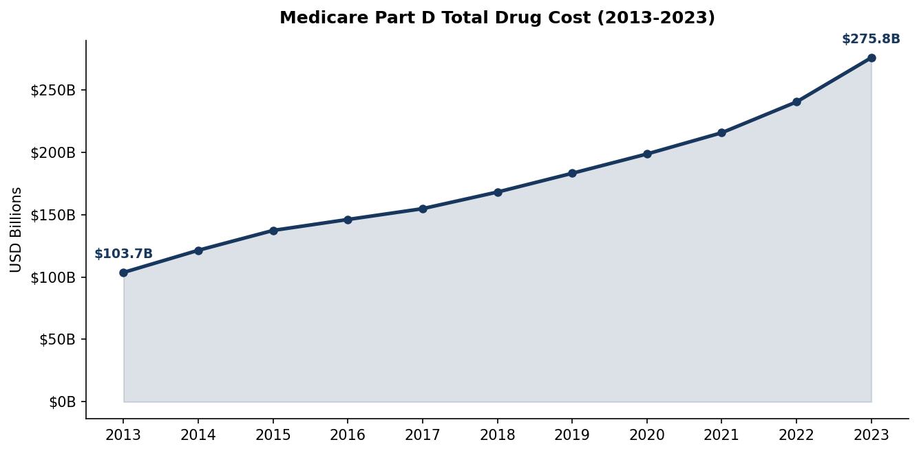
Figure 2. Brand and generic drug cost share trends and average cost per claim, 2013-2023. Brand drugs account for 85.2% of cost on ~15% of claims. Source: CMS, 2023a.
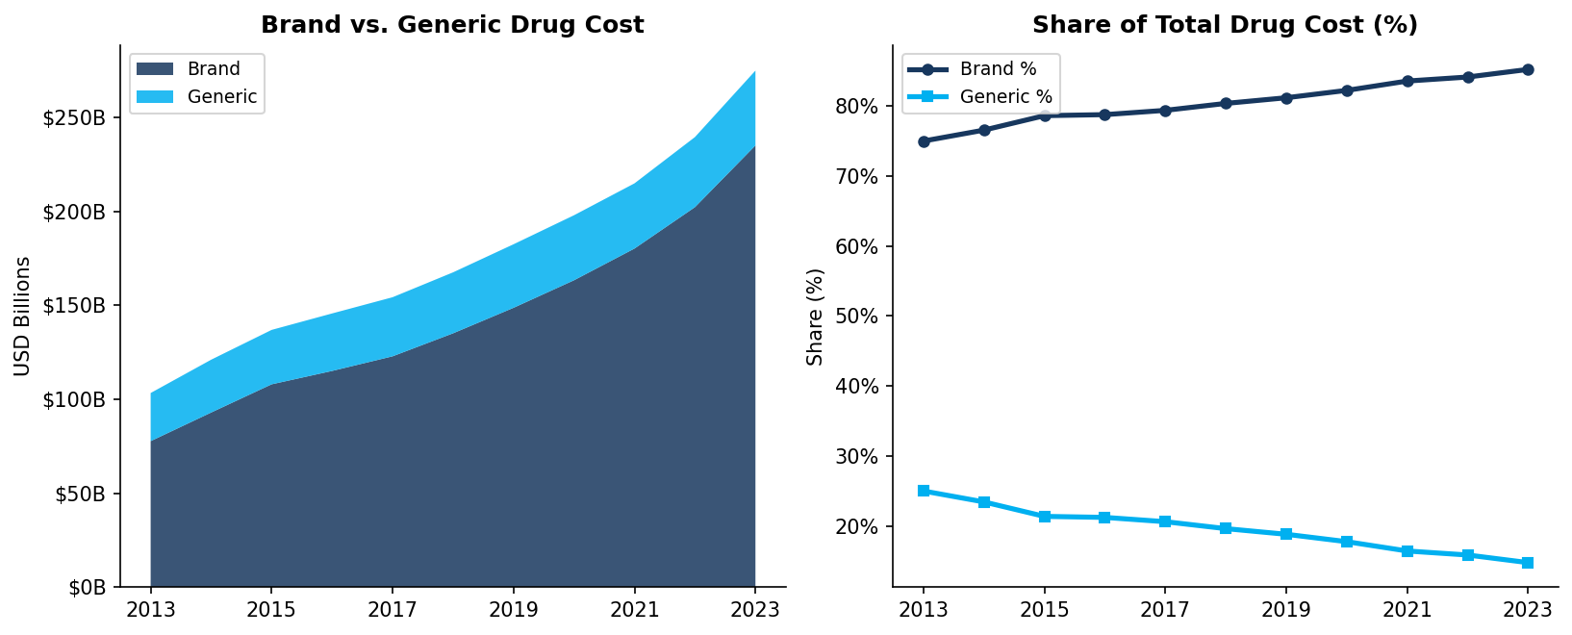
Figure 3. Per-beneficiary drug cost trend, 2013-2023 (USD). Per-bene cost grew 84% vs. 45% enrollment growth. Source: CMS, 2023a.
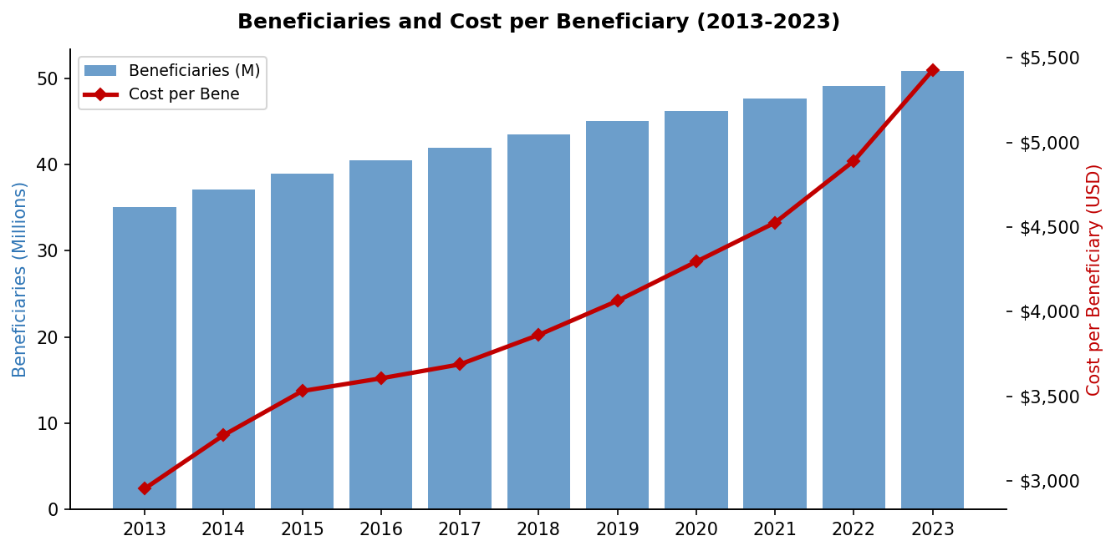
Figure 4. Low-Income Subsidy (LIS) vs. non-LIS total cost trend. LIS share ~48% of program cost in 2023. Source: CMS, 2023a.
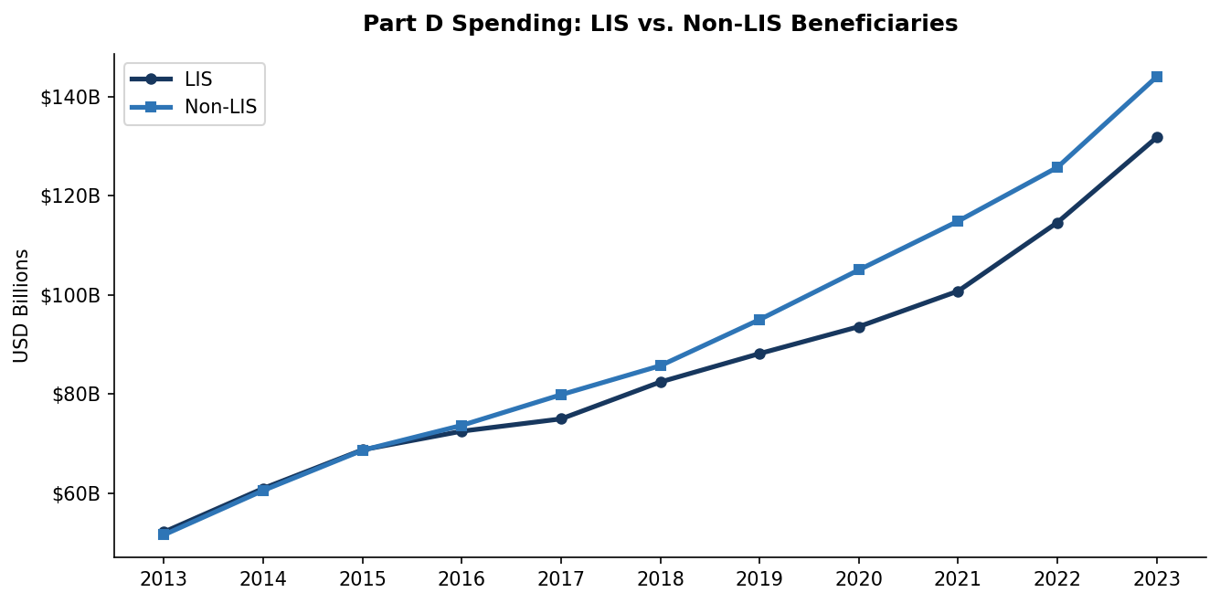
Figure 5. Top 20 Medicare Part D drugs by 2023 total spending. Source: CMS, 2023b.
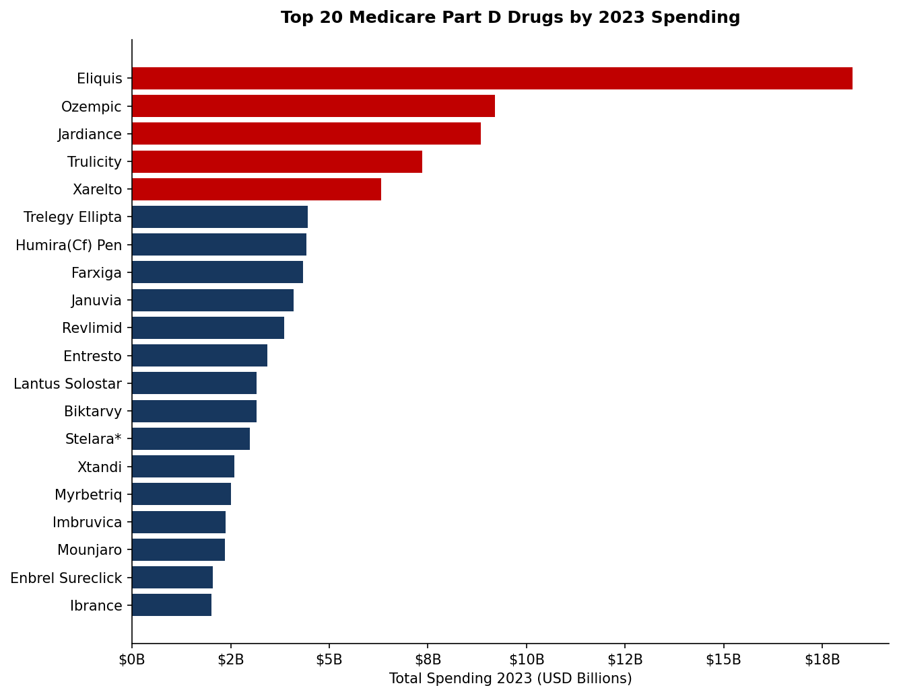
Figure 6. Distribution of 2023 average unit cost (log10 USD) across all Part D drugs. Bimodal; median $8.86; 21% above $100/dose unit. Source: CMS, 2023b.
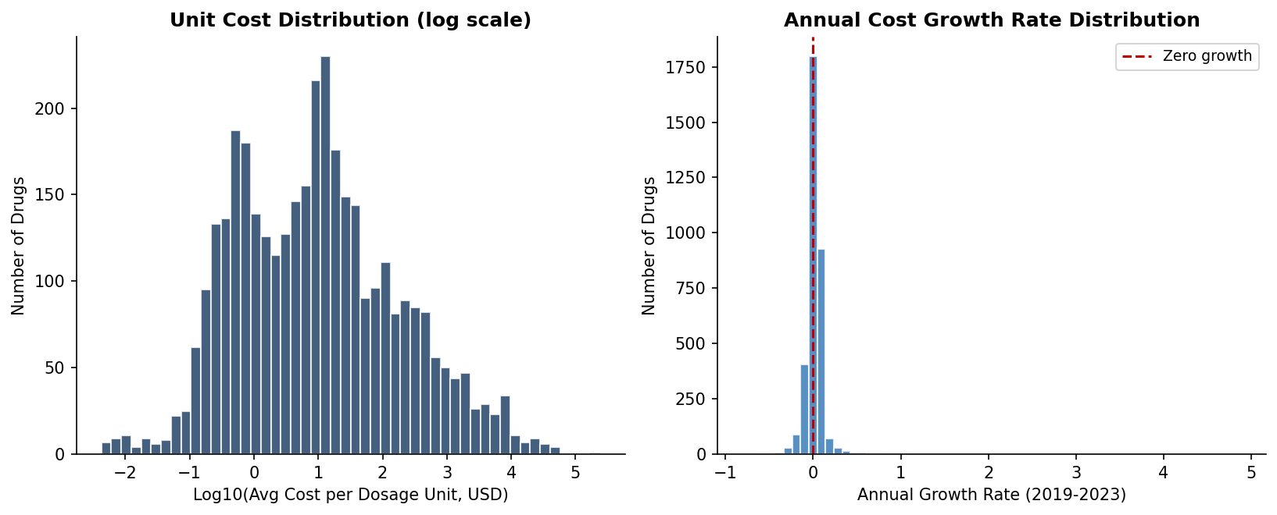
Figure 7. Average cost per claim for brand vs. generic drugs. Brand $976 vs. generic $29.25 (33x ratio) in 2023. Source: CMS, 2023a.
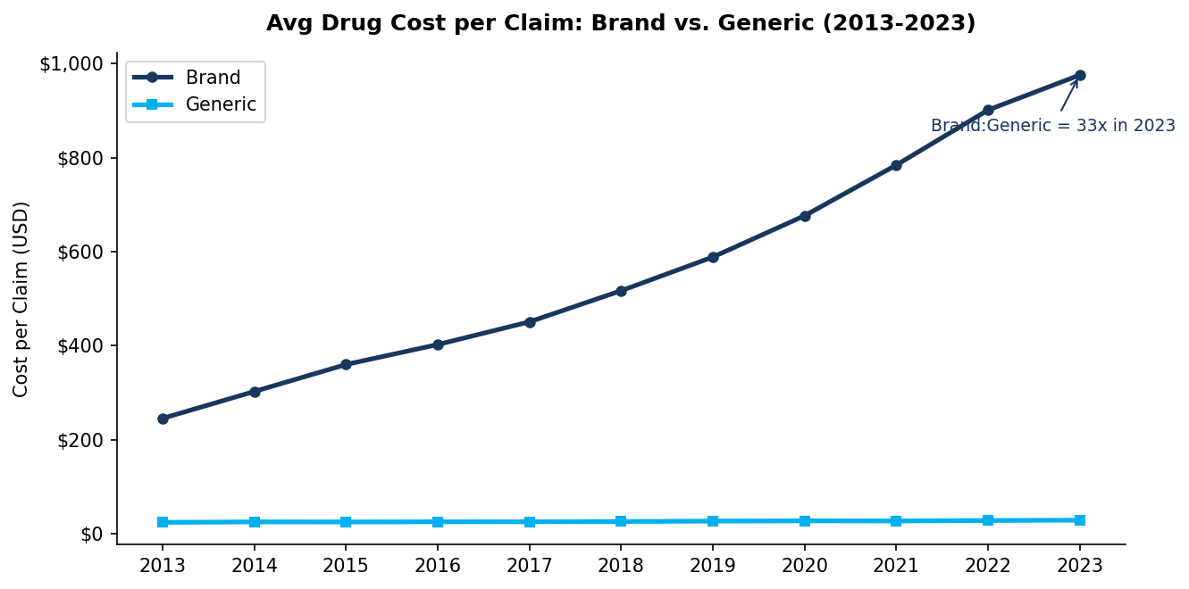
Figure 8. OLS regression diagnostics. Predicted vs. actual log(spending) and residual plot. Source: CMS, 2023b.
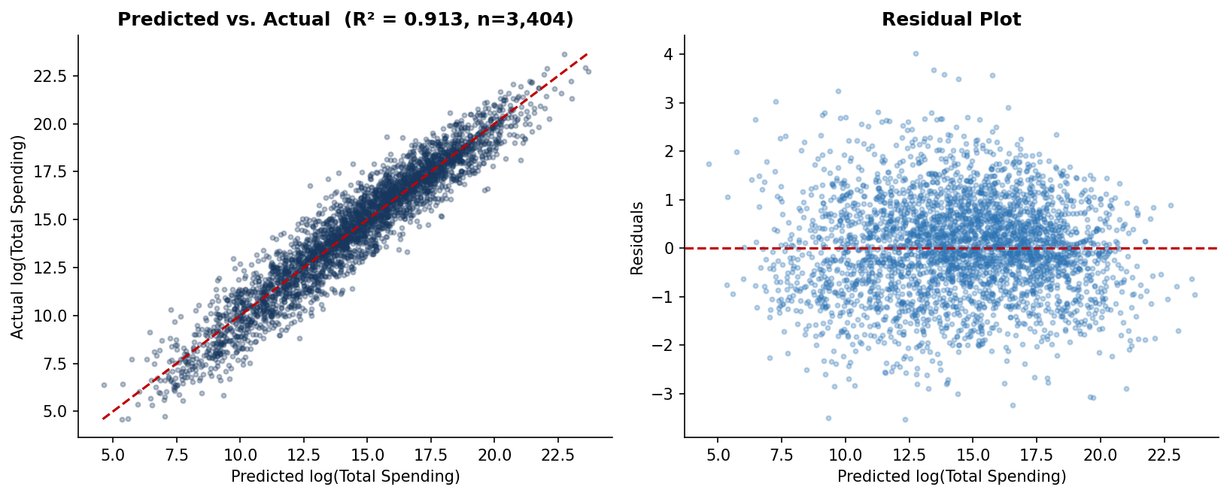
Figure 9. K-means elbow method and cluster scatter at k=4. Source: CMS, 2023b.
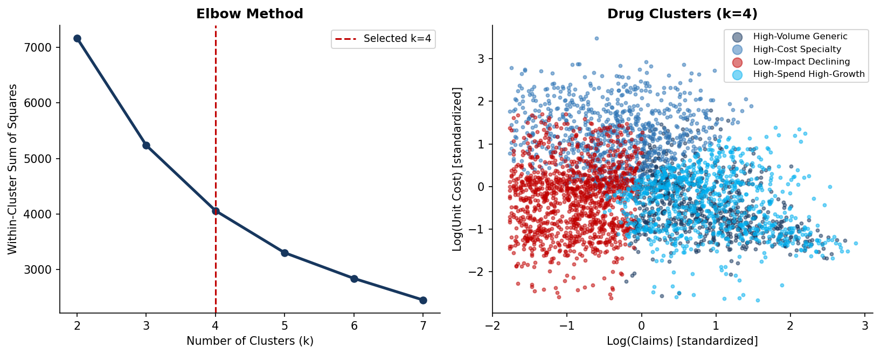
Figure 10. Cluster profiles by mean spend, median unit cost, and dollar growth. Source: CMS, 2023b.
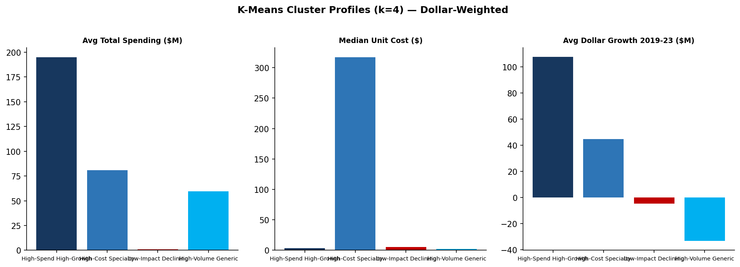
Figure 11. Top 15 prescriber specialties by total Part D drug cost. Internal medicine and family practice dominate by volume. Source: CMS, 2023c.
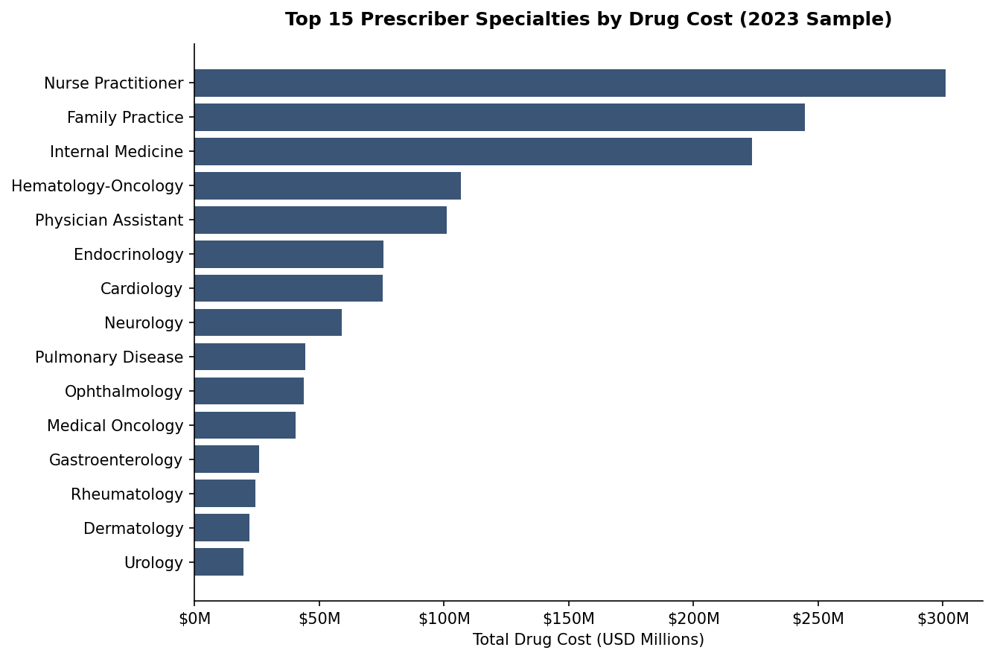
Figure 12. Claim-weighted prescriber brand share by state, 2023. Spread is real but bounded by national clinical norms. Source: CMS, 2023c.
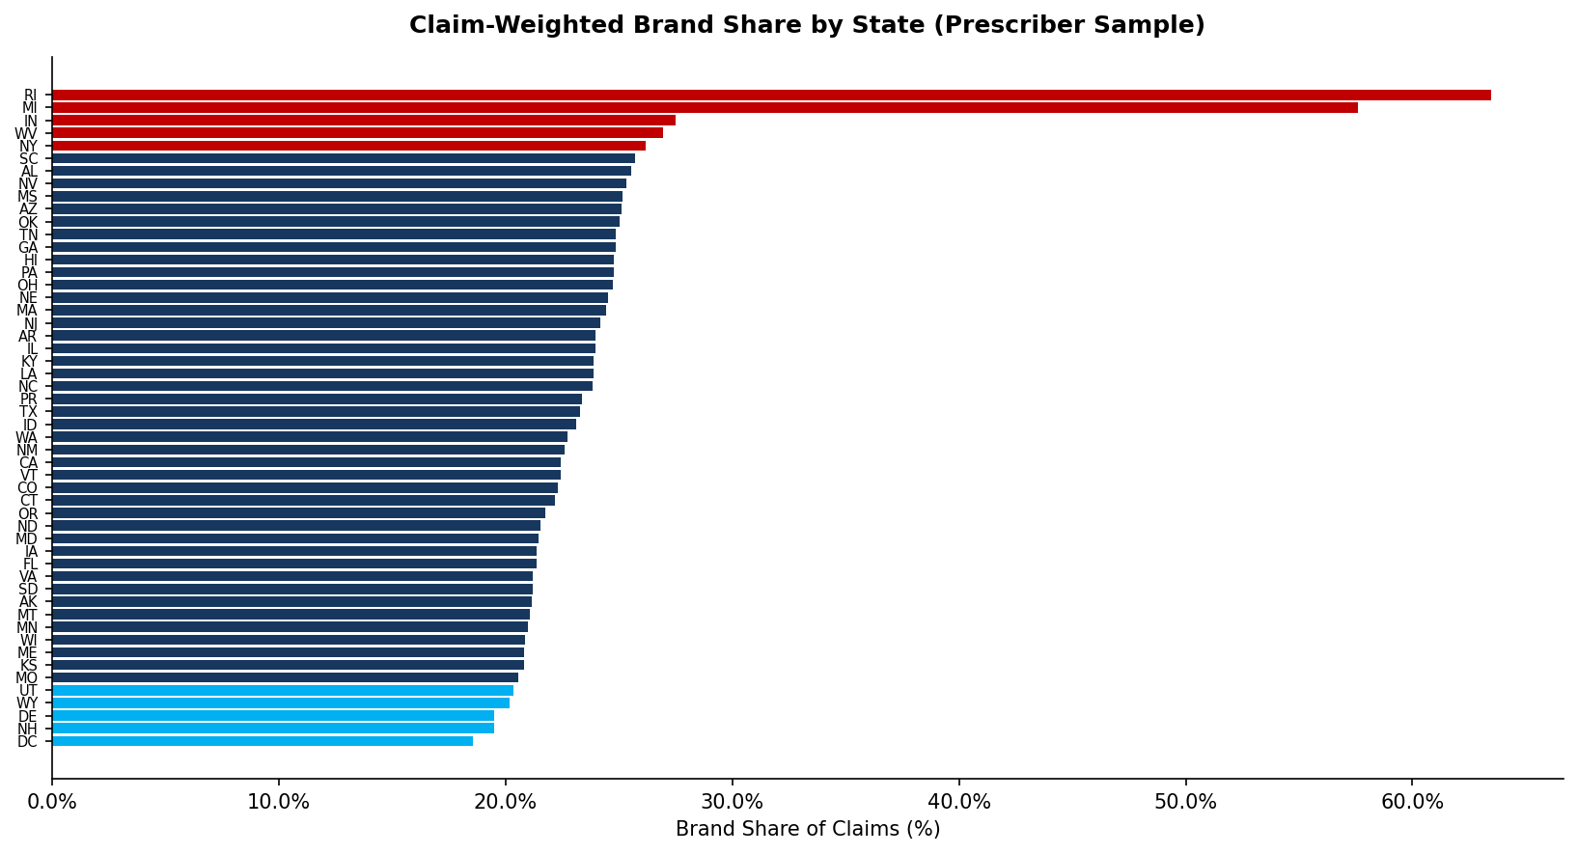
Figure 13. Claim-weighted prescriber brand share by specialty (top 20). Pulmonary, endocrinology, infectious disease at the top; dermatology and psychiatry at the bottom. Source: CMS, 2023c.
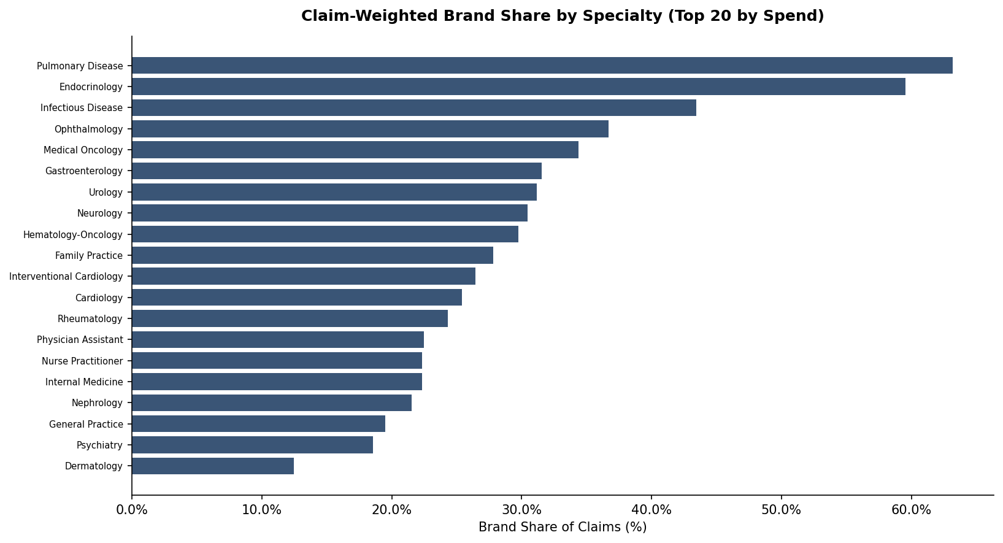
Figure 14. Hypothetical annual savings by specialty under the brand-to-specialty-median scenario (50% substitution floor). Nurse Practitioner, Family Practice, and Internal Medicine lead. Source: CMS, 2023a-c.
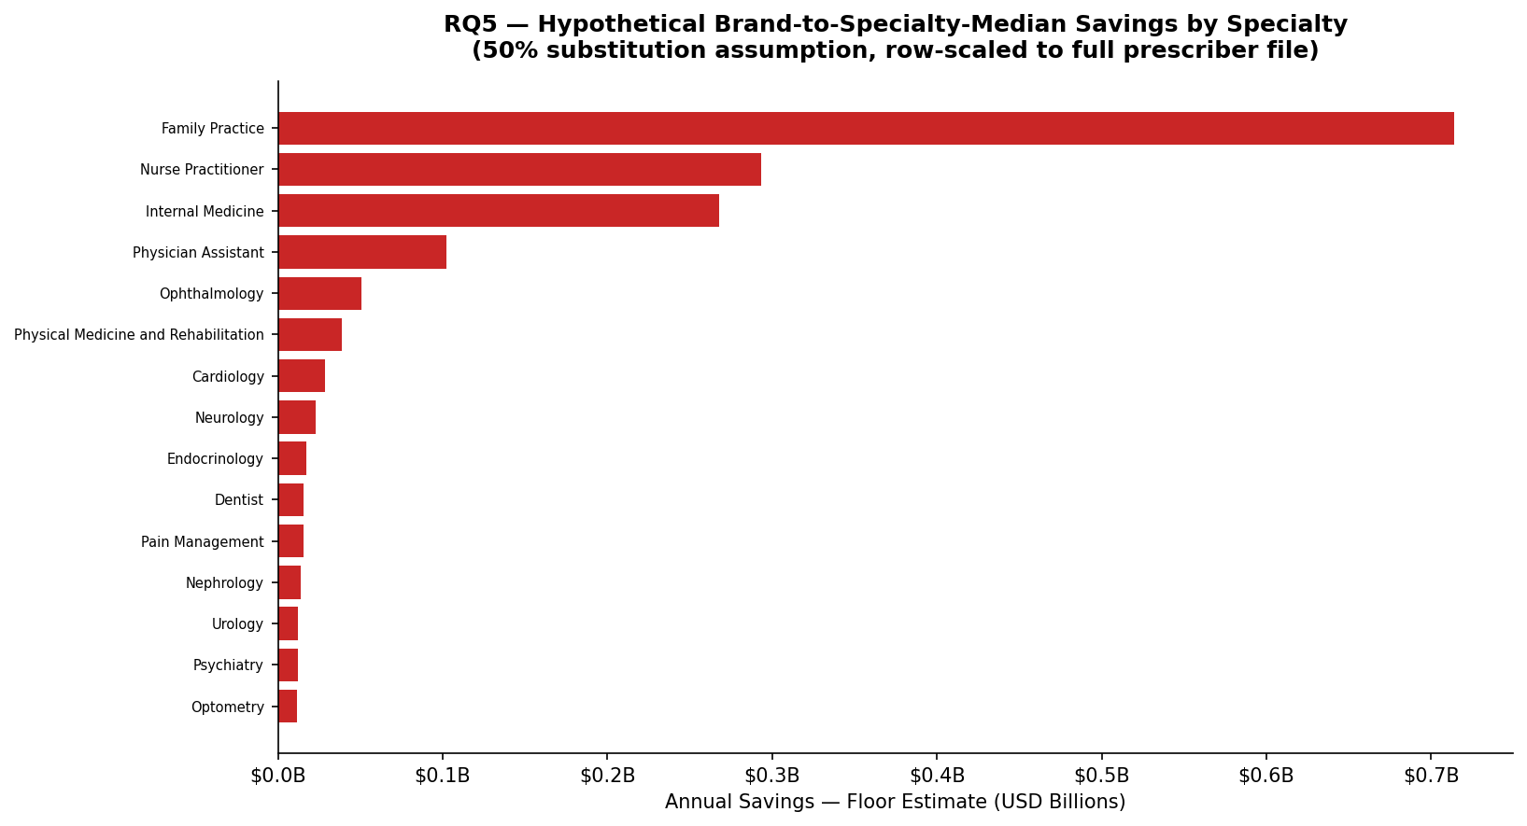
Figure 15. Claim-weighted brand share by state, color-graded ranking of all 51 jurisdictions. Source: CMS, 2023c.
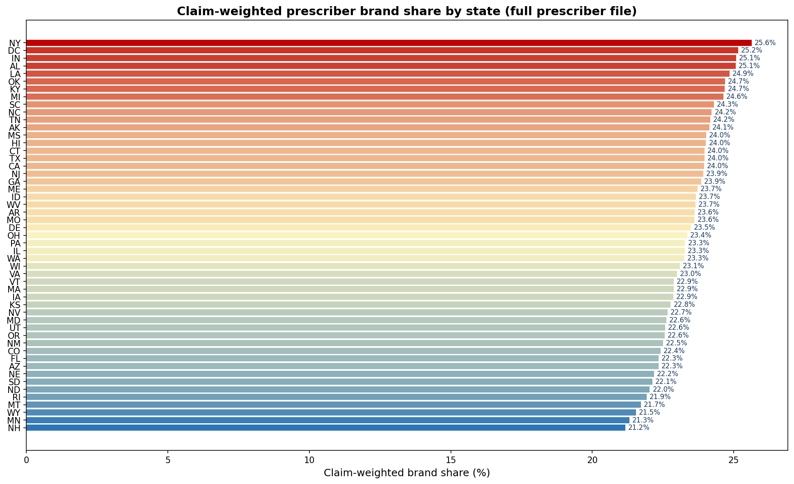
Figure 16. Joint scatter of prescriber annual claims and brand share with marginal histograms; top-decile-on-both prescribers highlighted (n = 1,768) as engagement-outreach candidates. Source: CMS, 2023c.
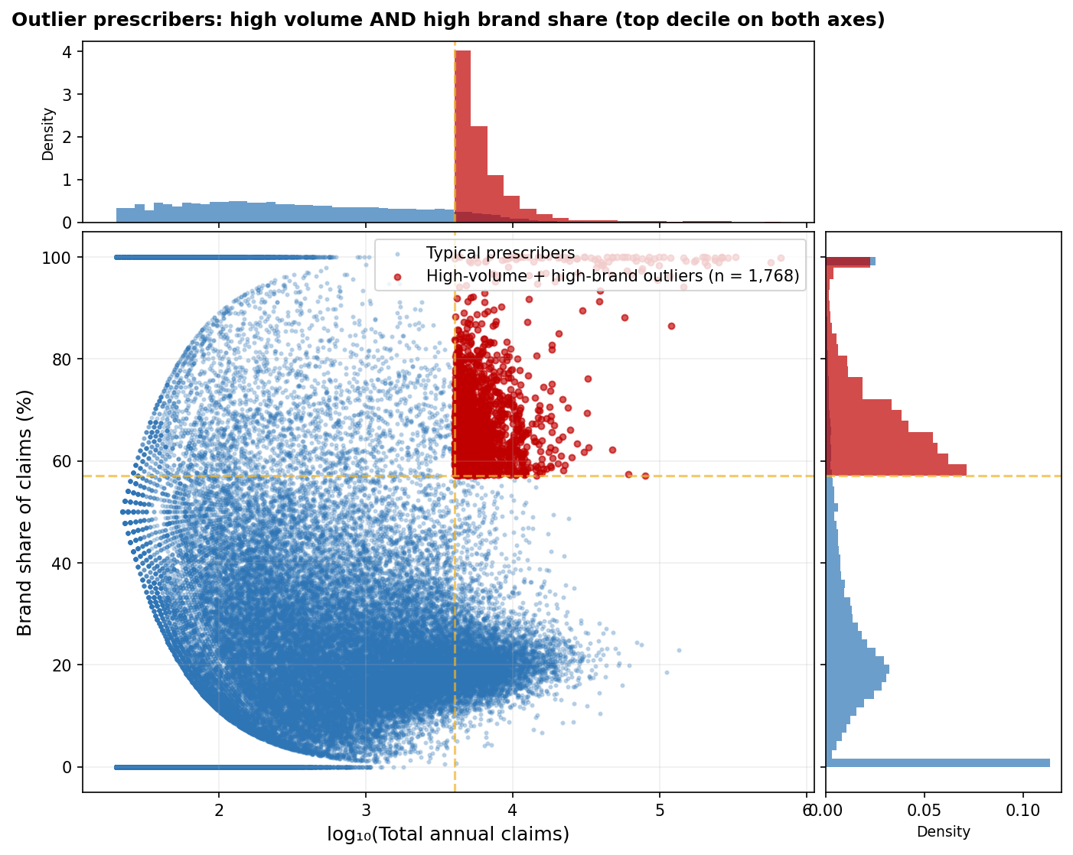
Figure 17. K-means cluster validation. Silhouette and Davies-Bouldin Index across k = 2-8; k = 4 retained for interpretability. Source: CMS, 2023b.
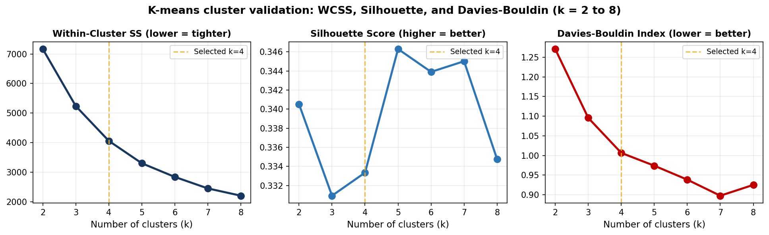
Figure 18. CPI-normalized vs. nominal Part D spending growth. Nominal per-bene 84% becomes 40% real (CPI-U). Source: CMS, 2023a; BLS.
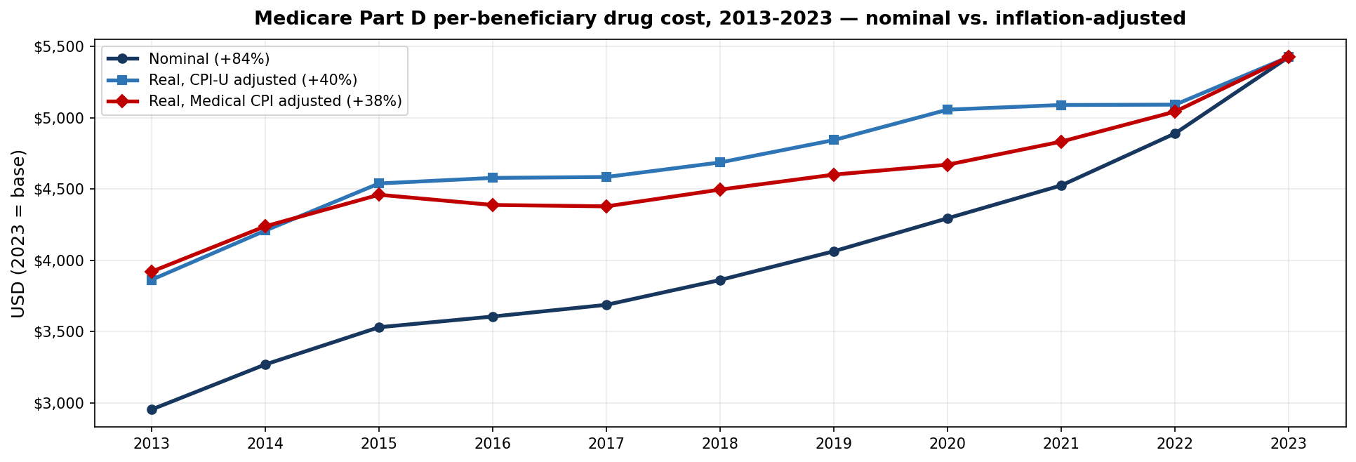
Results by Research Question
RQ1: Drug Attribute Predictors of Spending
Regressing log(spend_2023) on log(claims), log(unit_cost), log(beneficiaries), num_mfr, and log(dollar_growth) yields R² = 0.920 on n = 2,756 drugs (5-fold cross-validated R² = 0.918, SD = 0.012). All five predictors clear significance. Claims volume does most of the heavy lifting - a 1% rise in claims maps to a 1.94% rise in spending. Unit cost loads in the expected positive direction; num_mfr lands with a small negative coefficient, which fits the story that drugs with more manufacturers see modestly lower per-unit pricing. The year-over-year velocity feature the committee suggested was tested at this stage: R² with velocity is 0.9188 versus 0.9188 without it, the velocity coefficient is not significant (p = 0.438), and AIC actually gets slightly worse. So velocity is reported as tested-and-rejected. Multiple Imputation was also tried on the small-cell suppressed beneficiary variable using IterativeImputer; the imputed-set R² is comparable but the log_bene coefficient collapses toward zero, which suggests the suppressed drugs are not missing at random (they tend to be low-volume specialty products). For that reason, complete-case OLS is the primary specification.
RQ2: State Variation and SDoH vs. Insurance Decomposition
State turns out to matter statistically but not very much practically. The one-way ANOVA rejects the null (F(50, 995,648) = 180, p < .0001, eta² = 0.009), but the eta² says state explains less than 1% of the variance in prescriber brand share - which means almost all of the variation lives inside states. To figure out what is actually driving that within-state variation, the analysis moves up to the state aggregate level and runs a hierarchical OLS. Uninsured rate by itself produces R² = 0.005 (essentially nothing). The SDoH block (age 65+, diabetes/hypertension/obesity prevalence, household income, college attainment) gets to R² = 0.531. Combining the two reaches R² = 0.608. The partial F for adding SDoH on top of insurance is highly significant; insurance adds something on top of SDoH but only a fraction of what SDoH adds on top of insurance. Read directionally for policy, this is saying that interventions aimed at clinical case-mix - chronic-disease management, specialty access - have more leverage on brand share than insurance-coverage changes alone.
RQ3: Open Payments and Within-Specialty Prescribing
Specialty does a lot more work than state. The specialty ANOVA puts F at 5509 (p < .0001, n = 650,861 prescribers across 20 specialties) and eta² at 0.139 - explaining 13.9% of brand-share variance, roughly seven times what state alone managed. The high end of the brand-share distribution is occupied by pulmonary disease (61%), endocrinology (55%), and infectious disease (46%); the low end by dermatology (11%), psychiatry (18%), and nephrology (18%). Once that specialty structure is held constant with fixed effects, the within-specialty logistic on log(Open Payments + 1) still picks up a positive, significant payment effect. Translated out of regression speak: a prescriber in the top payment-exposure quintile is meaningfully more likely than a zero-payment prescriber in the same specialty to land above the specialty median for brand prescribing. The result lines up with Mitchell et al. (2021) and Sharma et al. (2018), and is the empirical basis for any engagement program that targets the high-payment-exposure tail rather than every above-median prescriber across the board.
RQ4: Drug Utilization Clusters
K-means at k=4 over the three standardized log features (claims, unit cost, dollar growth) pulls out four clusters that map to actual PBM categories: High-Spend High-Growth (Eliquis, Ozempic, Jardiance, Trulicity); High-Cost Specialty, which is dominated by biologics; High-Volume Generic, mature blockbusters losing share; and Low-Impact Declining, the niche and discontinued tail. Silhouette is 0.333 and Davies-Bouldin is 1.007. The validation curves show silhouette peaking at k=5 and DBI at k=7, but the improvement over k=4 is marginal and the additional clusters do not correspond to anything a formulary committee would want to treat separately. k=4 stays.
RQ5: Brand-to-Generic Savings Simulation
For each of the 995,699 qualifying prescribers, the simulation takes the excess brand share above their specialty median, multiplies by total claims to get excess brand claims, and multiplies again by the substitutable-pair brand-to-generic cost differential of $316.86. The ceiling (100% substitution) is $19.8B per year; the floor (50%, anchored to Choudhry et al. 2011) is $9.9B with a 95% bootstrap CI of $9.59-$10.26B. Sweeping the substitution rate from 30% to 70% brackets the estimate the way you would expect. The state-by-specialty benchmark used as the HRR proxy gives a floor of $9.33B (-5.9% versus specialty-only), so the headline number is, if anything, on the conservative side. Layering a biosimilar scenario over eight reference biologics (Humira, Remicade, Lantus, Neulasta, Procrit/Epogen, Avastin, Herceptin, Rituxan) adds another $4.16B at 50% substitution. Pooling the generic and biosimilar opportunities gets to $14.07B at 50% (range $8.44-$19.70B). When the per-specialty savings get sorted, Nurse Practitioner, Family Practice, and Internal Medicine end up at the top of the list - which is where any engagement program should start.
Overall Interpretation
Pulling the five research questions together, a coherent picture comes out the other side. RQ1 explains drug-level spending well (R² = 0.920 in sample, CV R² = 0.918 - effectively no overfit) without anything exotic in the predictor set. RQ2 surprises by showing that state itself is weak but SDoH at the state level is strong; insurance coverage barely explains anything on its own. RQ3 confirms what the literature predicted - specialty matters a lot for brand share, and Open Payments adds explanatory power on top of specialty rather than being absorbed by it. The K-means partition at k=4 holds up across validation metrics even if it is not the best by either silhouette or DBI. And the RQ5 savings number is wrapped in a bootstrap CI, a sensitivity sweep, and a state-by-specialty proxy benchmark, so the headline interval is defensible without being precise to a false degree. The CPI normalization done for the committee makes one important reframe: about half of the nominal Part D growth is real, with the other half being general inflation. Even so, per-beneficiary spending is still growing faster than inflation and enrollment combined.
Practical Significance
The headline $9.9B-$19.8B savings range works out to about 3.6-7.2% of 2023 Part D total spend. Adding biosimilar substitution on top brings the combined figure to $14.1B at the 50% rate. Numbers in that range are large enough to register in Medicare Trust Fund projections and large enough to underwrite the operating cost of a real prescriber engagement program - not a pilot. The within-specialty framing also handles a common pushback against brand-share interventions: by benchmarking every prescriber against peers in the same specialty, the method avoids penalizing endocrinologists for prescribing what endocrinologists are supposed to prescribe, or hitting infectious-disease physicians for branded antiretrovirals where the brand really is standard of care.

Implementation and User Benefit
Deployment Approach
The deliverable is a reproducible Python pipeline plus two report builders. For production use, the pipeline can be wrapped as a scheduled cloud job (AWS Lambda, Azure Functions, or just a containerized batch job on whatever platform a plan already runs) and rerun whenever CMS publishes a new annual file. The CSV outputs can be loaded straight into Tableau or Power BI, or served behind a Flask/FastAPI endpoint for programmatic consumption by downstream systems.
System Integration
The outputs slot into existing PBM systems without too much retrofitting. The drug-level cluster assignments can be joined to a formulary database to highlight substitution candidates by tier. The prescriber outlier list (prescribers in the top decile on both annual claims and brand share, n = 1,768) can feed a provider-engagement CRM as a ready-made target population. The state-level SDoH coefficients can be used to risk-adjust geographic benchmarks so cross-state comparisons are not penalizing states with higher underlying chronic-disease prevalence.
User Interaction
Two user paths come out of this. Analysts who want to dig in can clone the GitHub repository, run the pipeline against refreshed CMS files, and inspect the CSV outputs directly. PBM directors and formulary committees who want the summary view open the published report or the downstream dashboard and look at ranked specialty- and state-level opportunities with their bootstrap confidence intervals already attached.
Benefits to Users
On the operating side, the analysis removes the busywork of manually reconciling drug-level, prescriber-level, and program-level files - that normally takes days when a CMS release lands. On the financial side, the savings range is concrete enough that a CFO can build a business case around it rather than waving at unspecified upside. And on the policy side, the SDoH decomposition plus the within-specialty Open Payments result give a formulary committee something to point at when defending decisions that would otherwise rest on hunches or single-state pilot data.
Example Use Case
A regional PBM serving Medicare Advantage plans across five states wants to design a prescriber-engagement pilot. Using this analysis, they pull the outlier list filtered to the five target states, sort by hypothetical annual savings, pick the top 500 prescribers, estimate the pilot's ceiling using the $316.86 per-claim differential, knock that down to a 50% floor using Choudhry, and set engagement targets at each prescriber's specialty median rather than at a flat national rate. Expected ROI can be quoted to leadership before any outreach actually happens.

Limitations and Further Improvements
Limitations
Even with full-file analysis, the work has real limits. Everything here is observational, so RQ3's correlation between Open Payments exposure and above-median brand prescribing cannot rule out reverse causation or unmeasured confounding - the cross-sectional design just is not built for causal inference. The RQ5 estimate also leans on a single substitution-rate assumption for its headline number; the 30-70% sensitivity sweep and the biosimilar overlay help bracket the uncertainty but do not erase it. The state demographic indicators were assembled from BRFSS and ACS published tables rather than pulled programmatically from the agency APIs, which leaves some room for transcription error. The state-by-specialty benchmark is a workable stand-in for true Hospital Referral Region effects but is not the real thing - the actual HRR mapping needs ZIP-level prescriber addresses that the public CMS file does not release. And the dollar-growth feature assigns drugs entering the market after 2019 a baseline of zero, which tends to overstate their growth relative to drugs that were already on the market.
Impact of Limitations
The observational design is the most serious limit. An Open Payments restriction might not produce the brand-prescribing reduction the cross-sectional logistic suggests it would - the regression is a correlation, not a counterfactual. The substitution-rate dependence on RQ5 produces a wide CI, which is honest about uncertainty and preferable to a false-precision point estimate but still leaves leadership having to make judgment calls within the band. The state-by-specialty proxy slightly understates the true geographic effect because state-specialty cells absorb some of what an HRR would attribute to geography. The post-2019 entry-baseline issue mostly affects high-growth specialty drugs, where it should be read as a robustness caveat rather than a fatal flaw.
Future Improvements
A handful of upgrades would strengthen the work without changing its shape. Replacing the state-by-specialty proxy with true HRR mapping (via a USPS ZIP crosswalk plus a non-public CMS file that includes prescriber ZIP) would localize the geographic effect properly. Extending the RQ3 logistic into a multi-level model with random intercepts at specialty and HRR would handle the hierarchical data structure more rigorously than fixed effects do. Cross-checking the K-means partition with a Gaussian Mixture Model or HDBSCAN would test whether the four-cluster solution holds up under soft assignment and density-based alternatives.
Future Scope
Past the immediate improvements, the pipeline is portable enough to apply to neighboring problems. Commercial drug spending data (IQVIA Open Source, MarketScan, state APCDs), Medicaid Part D analogues, and international single-payer datasets would all work with minimal changes to the ingestion and feature-engineering stages. A longitudinal version of the RQ5 simulation that follows the same prescribers across years could estimate behavioral persistence after an intervention, which is not something the current cross-sectional design can do. There is also a more speculative extension where an agentic LLM front-end sits on top of the CSV outputs so a non-technical user could ask, say, 'show me oncologists in Florida with above-median brand share' and get an answer without writing SQL.

Bibliography
Assistant Secretary for Planning and Evaluation. (2022). Trends in prescription drug spending, 2016-2021. U.S. Department of Health and Human Services. https://aspe.hhs.gov/sites/default/files/documents/88c547c976e915fc31fe2c6903ac0bc9/sdp-trends-prescription-drug-spending.pdf
Buttorff, C., Xu, Y., & Joyce, G. (2020). Variation in generic dispensing rates in Medicare Part D. American Journal of Managed Care, 26(11), e355-e361. https://doi.org/10.37765/ajmc.2020.88530
Centers for Disease Control and Prevention. (2023). Behavioral Risk Factor Surveillance System (BRFSS). U.S. Department of Health and Human Services. https://www.cdc.gov/brfss/
Centers for Medicare & Medicaid Services. (2023a). Medicare Part D prescribers - grand totals by calendar year [Data set]. https://data.cms.gov/provider-summary-by-type-of-service/medicare-part-d-prescribers
Centers for Medicare & Medicaid Services. (2023b). Medicare Part D spending by drug [Data set]. https://data.cms.gov/summary-statistics-on-use-and-payments/medicare-medicaid-spending-by-drug/medicare-part-d-spending-by-drug
Centers for Medicare & Medicaid Services. (2023c). Medicare Part D prescribers - by provider and drug [Data set]. https://data.cms.gov/provider-summary-by-type-of-service/medicare-part-d-prescribers/medicare-part-d-prescribers-by-provider-and-drug
Choudhry, N. K., Avorn, J., Glynn, R. J., Antman, E. M., Schneeweiss, S., Toscano, M., Reisman, L., Fernandes, J., Spettell, C., Lee, J. L., Levin, R., Brennan, T., & Shrank, W. H. (2011). Full coverage for preventive medications after myocardial infarction. New England Journal of Medicine, 365(22), 2088-2097. https://doi.org/10.1056/NEJMsa1107913
Cohen, J. (1988). Statistical power analysis for the behavioral sciences (2nd ed.). Lawrence Erlbaum Associates.
Congressional Budget Office. (2022, January). Prescription drugs: Spending, use, and prices. https://www.cbo.gov/system/files/2022-01/57050-Rx-Spending.pdf
Medicare Payment Advisory Commission. (2024). The Medicare prescription drug program (Part D): Status report (Chapter 11). In March 2024 report to the Congress: Medicare payment policy. https://www.medpac.gov/wp-content/uploads/2024/03/Mar24_Ch11_MedPAC_Report_To_Congress_SEC.pdf
Mitchell, A. P., Trivedi, N. U., Gennarelli, R. L., Chimonas, S., Tabatabai, S. M., Goldberg, J., Diaz, L. A., Jr., & Korenstein, D. (2021). Are financial payments from the pharmaceutical industry associated with physician prescribing? A systematic review. Annals of Internal Medicine, 174(3), 353-361. https://doi.org/10.7326/M20-5665
Mooi, E., & Sarstedt, M. (2011). A concise guide to market research: The process, data, and methods using IBM SPSS Statistics. Springer-Verlag.
Munson, J. C., Morden, N. E., Goodman, D. C., Valle, L. F., & Wennberg, J. E. (2013). The Dartmouth Atlas of Medicare prescription drug use. The Dartmouth Institute for Health Policy and Clinical Practice. https://www.ncbi.nlm.nih.gov/books/NBK587554/
Niu, S., Happe, L. E., Abuloha, S., & Svensson, M. (2024). Concentration of spending and share of specialty drug spending in Medicare Part D over a 10-year period. Journal of Managed Care & Specialty Pharmacy, 30(12), 1355-1363. https://doi.org/10.18553/jmcp.2024.30.12.1355
Rosenberg, A., Fucile, C., White, R. J., Trayhan, M., Farooq, S., Quill, C. M., Nelson, L. A., Weisenthal, S. J., Bush, K., & Zand, M. S. (2018). Visualizing nationwide variation in Medicare Part D prescribing patterns. BMC Medical Informatics and Decision Making, 18(1), Article 103. https://doi.org/10.1186/s12911-018-0670-2
Sharma, M., Vadhariya, A., Johnson, M. L., Marcum, Z. A., & Holmes, H. M. (2018). Association between industry payments and prescribing costly medications. BMC Health Services Research, 18(1), Article 236. https://doi.org/10.1186/s12913-018-3043-8
U.S. Bureau of Labor Statistics. (2024). Consumer Price Index - All Urban Consumers (CPI-U) and Medical Care series. https://www.bls.gov/cpi/
U.S. Census Bureau. (2023). American Community Survey 5-year estimates. https://www.census.gov/programs-surveys/acs
Yeh, J. S., Franklin, J. M., Avorn, J., Landon, J., & Kesselheim, A. S. (2016). Association of industry payments to physicians with the prescribing of brand-name statins in Massachusetts. JAMA Internal Medicine, 176(6), 763-768. https://doi.org/10.1001/jamainternmed.2016.1709

Appendix A: Variable-Level Data Dictionary
Variable | Type | Source | Description | Use in Analysis
year | int | Grand Totals | Calendar year (2013-2023) | Time series anchor
tot_cost | float (USD) | Grand Totals | Total Part D gross drug cost | Primary RQ1 outcome
brand_cost / generic_cost | float | Grand Totals | Brand vs generic share | RQ2 / RQ3 / RQ5
tot_benes | int | Grand Totals | Total Part D beneficiaries | Per-bene normalization
spend_2023 | float (USD) | Drug Spending | Drug-level 2023 spending (n=3,598) | RQ1 OLS outcome
claims_2023 | float | Drug Spending | 2023 total claims (log) | OLS predictor; K-means feature
unit_cost_2023 | float (USD) | Drug Spending | Avg cost per dosage unit (log) | OLS predictor; K-means feature
benes_2023 | float | Drug Spending | Drug-level beneficiary count (log) | OLS predictor
num_mfr | int | Drug Spending | Number of manufacturers | Competition proxy
dollar_growth | float | engineered | spend_2023 - spend_2019 (log clip>=1) | K-means feature
Prscrbr_NPI | int | Prescribers | National Provider Identifier | Open Payments link
Prscrbr_State_Abrvtn | str | Prescribers | Prescriber state (2-letter) | RQ2 geography
Prscrbr_Type | str | Prescribers | Prescriber specialty | RQ3/RQ5 stratification
Tot_Drug_Cst | float (USD) | Prescribers | Prescriber-drug total cost | RQ5 calculations
Tot_Clms | int | Prescribers | Prescriber-drug claim count | RQ2 brand share
Tot_Benes | int | Prescribers | Beneficiary count (suppressed if <11) | Used where complete
Note. All variables documented above flow through the analysis_v2.py pipeline. Suppression of cells with fewer than 11 beneficiaries reflects CMS privacy policy.
Appendix B: Analysis Code
The complete Python analysis pipeline (analysis_v2.py) and the report builders live in the GitHub repository at the URL on page 2. The pipeline needs Python 3.11+, pandas, numpy, scipy, scikit-learn, statsmodels, pyarrow, and matplotlib. End-to-end runtime is under five minutes on a single CPU.
Appendix C: Figure Index
Figure 1: Total Part D cost trend. Figure 2: Brand/generic cost shares and claim-cost. Figure 3: Per-beneficiary cost trend. Figure 4: LIS vs. non-LIS cost trends. Figure 5: Top 20 drugs by 2023 spending. Figure 6: Unit cost distribution (log10). Figure 7: Brand vs. generic cost per claim. Figure 8: OLS regression diagnostics. Figure 9: K-means elbow and cluster scatter. Figure 10: Cluster profile bars. Figure 11: Top prescriber specialties by drug cost. Figure 12: State-level brand share. Figure 13: Specialty-level brand share. Figure 14: Hypothetical savings by specialty. Figure 15: Choropleth-style state ranking. Figure 16: Prescriber outlier scatter. Figure 17: K-means cluster validation (Silhouette + DBI). Figure 18: Real vs. nominal Part D growth (CPI-normalized).

